Alicia Young

March 7, 2022

IT FDN 110 A

Assignment 8

<https://github.com/aliciay22/IntroToProg-Python-Mod07>

**Python Classes**

**Introduction**

The goal of this lesson is to write a script that uses classes. In Python, classes are a way to group data and functions together, and usually classes focus of either on data or processing.

**Process**

The first class in the script is called product, and it stores data about a product.

Constructors are functions that run when an object of the class is created. In this example, the constructor includes two parameters, one for the product name and one for the product price.

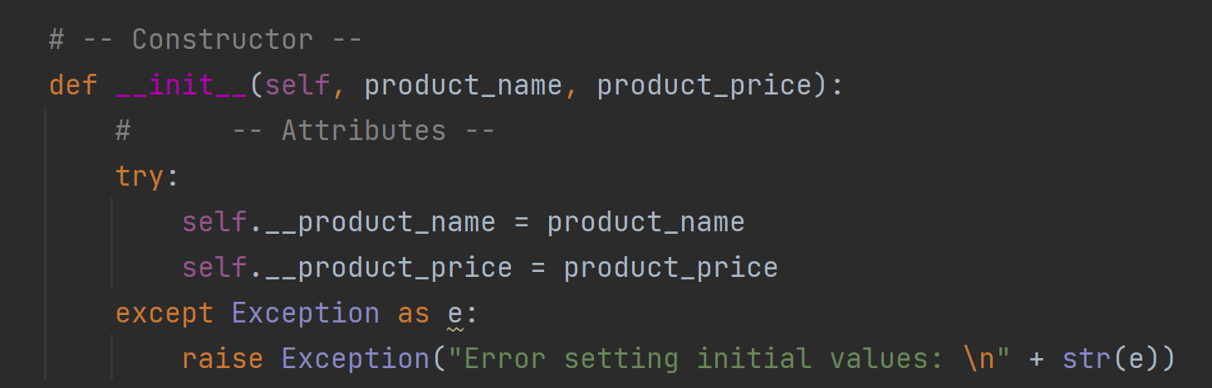

Properties are functions that are used to manage the attribute data of the class. Each attribute usually has two properties, one for getting the data and one for setting the data. These are often called “getters” and “setters” or “accessors” and “mutators.” In this example, the two parameters, product name and product price, each have both a getter and a setter.

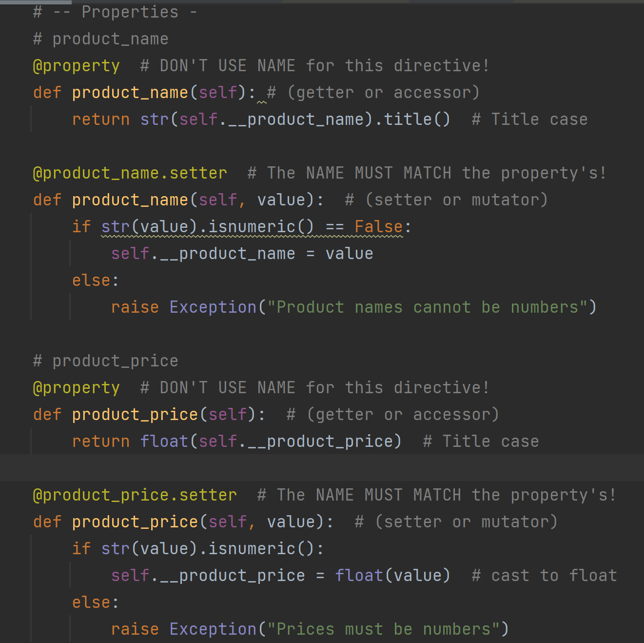

Methods are functions which reside inside a class. Similar to functions in scripts, methods are used to organize processing statements into named groups.

The second class in this script is called FileProcessing, and this class includes methods for processing the data both to and from a file.

Finally, the last class in this script, is called IO, and it includes methods for input and output tasks.

**Summary**

This script demonstrates how to use classes for data elements and data processing. Classes are used to define particular types of objects, and they define what methods can be used to change these objects.